**Group 3 - Lab 10**

***Application of Web3***

*Decentralized Autonomous Organizations*

*A decentralized autonomous organization (DAO) is an entity with no central leadership. Decisions get made from the bottom-up, governed by a community organized around a specific set of rules enforced on a blockchain.*

*DAOs are internet-native organizations collectively owned and managed by their members. They have built-in treasuries that are only accessible with the approval of their members. Decisions are made via proposals the group votes on during a specified period.*

*A DAO works without hierarchical management and can have a large number of purposes. Freelancer networks where contracts pool their funds to pay for software subscriptions, charitable organizations where members approve donations and venture capital firms owned by a group are all possible with these organizations.*

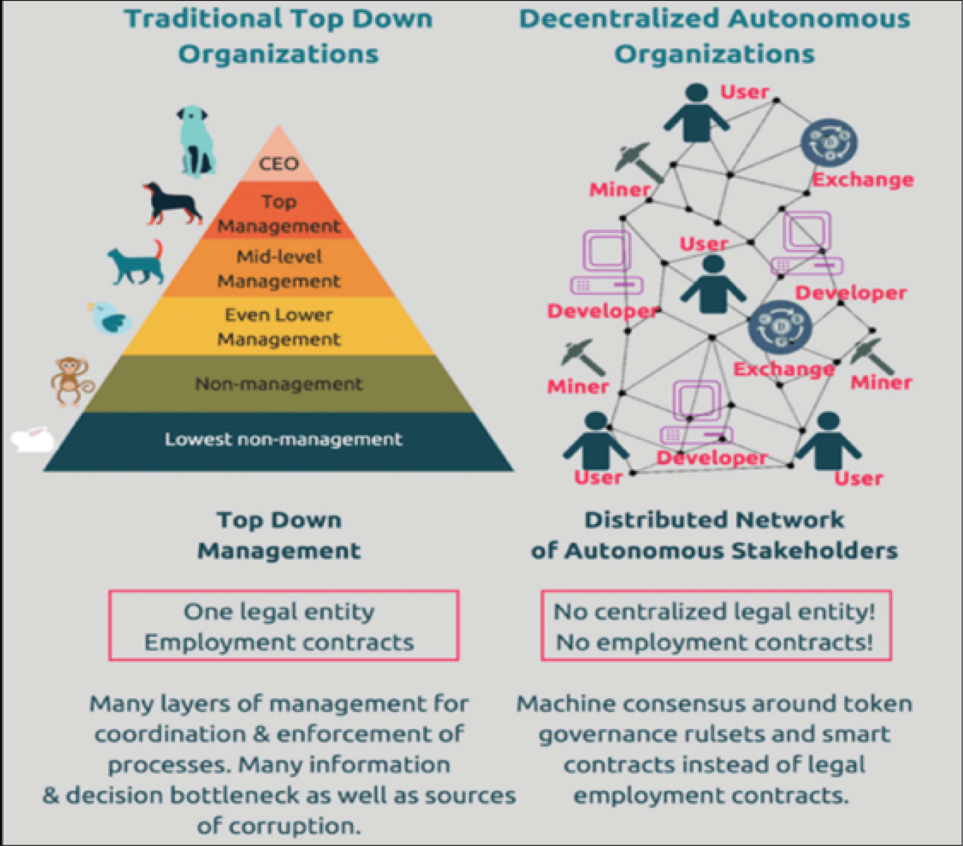

**How does a DAO work?**

As mentioned above, a DAO is an organization where decisions get made from the bottom-up; a collective of members owns the organization. There are various ways to participate in a DAO, usually through the ownership of a token.

DAOs operate using smart contracts, which are essentially chunks of code that automatically execute whenever a set of criteria are met. Smart contracts are deployed on numerous blockchains nowadays, though Ethereum was the first to use them.

These smart contracts establish the DAO’s rules. Those with a stake in a DAO then get voting rights and may influence how the organization operates by deciding on or creating new governance proposals.

This model prevents DAOs from being spammed with proposals: A proposal will only pass once the majority of stakeholders approve it. How that majority is determined varies from DAO to DAO and is specified in the smart contracts.

DAOs are fully autonomous and transparent. As they are built on open-source blockchains, anyone can view their code. Anyone can also audit their built-in treasuries, as the blockchain records all financial transactions.

**Benefits of using DAO**

1. **Operate via a computer code**

Whereas traditional organizations are run by specific leaders, DAOs operate through computer code. Blockchain-based governance ensures that no single individual controls the community. So, decisions are made faster in a transparent manner. An experienced blockchain development company can assist you to develop a DAO and incorporate intelligent contracts into it for faster operation.

1. **Use of smart contracts**

DAOs derive their consensus via digital contracts that exist on the blockchain spine. The virtual contracts are self-executing and contain immutable data that are tamperproof. The algorithms integrate sophisticated data and do away with the requirement for human direction. That said, decision-making through DAO is faster and more convenient. With DAO, you don’t need the physical presence of individuals to vote over an issue. A blockchain developer who is good at ethereum contract development can help you create smart contracts for DAO. The DAO smart contracts have the following information:

* Rules and regulations
* Guidelines
* Functionalities
* Contract address

1. **Instant trust and Transparency**

The best thing about DAO development is that they offer immediate trust and transparency for entities to focus on achieving their collective interests. The participants don’t need to know each other as the rules of engagement are embedded in a transparent, safe, and open-source blockchain record. Because blockchain ledger is tamperproof, no participant can alter the practices without a majority vote. So, the only role of a DAO entity is to advance the collective interest of a group.

1. **Community-based**

Unlike traditional organizations, DAOs have an even organizational structure with zero management. Within the organization, each token-holder has voting rights. At DAO development stage, one of the code rules indicates the voting power is dependent on the number of tokens one holds. No member has any additional privileges or rights other than others. So, an experienced ethereum development company understands this requirement before creating the code.

Initially, individuals meet at various social networking sites and decide to contribute funds using ethereum contract development. After collecting funds, the group agrees on achieving its mission as a single entity.